**HUMAN-ROBOT TOUCH INTERACTION EXPERIMENT PROTOCOL**

**Language setting :**

This game has Dutch and English versions, what's more, the nao robot could also speak Dutch and English, and you can choose your preferred language set.

**Procedures:**

Please follow the process below one by one.

1. Language setting: Choose your preferred language at the right bottom by clicking different buttons. The top button is "dutch," and the bottom one is "English."

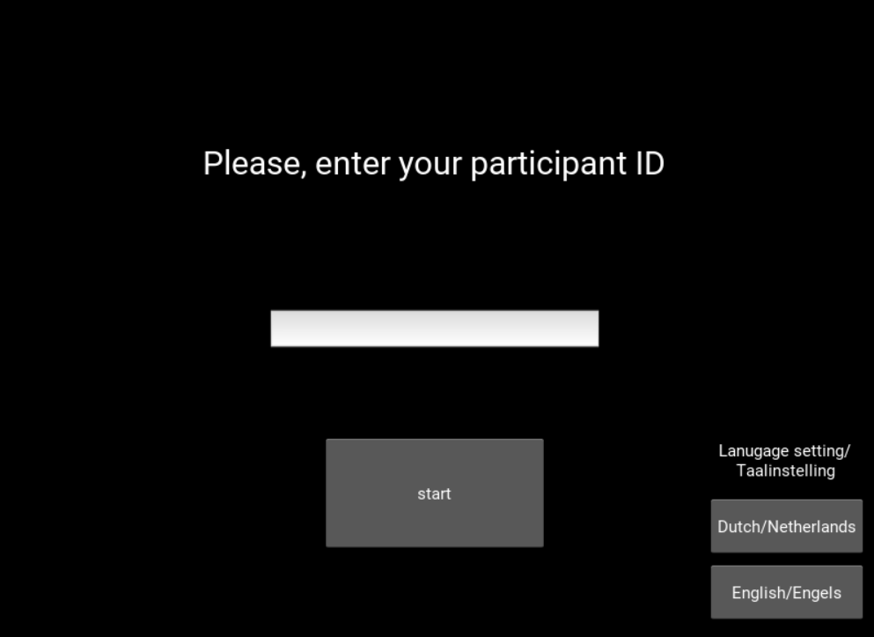

1. Please input your participant's ID, which is on the note distributed to you before.

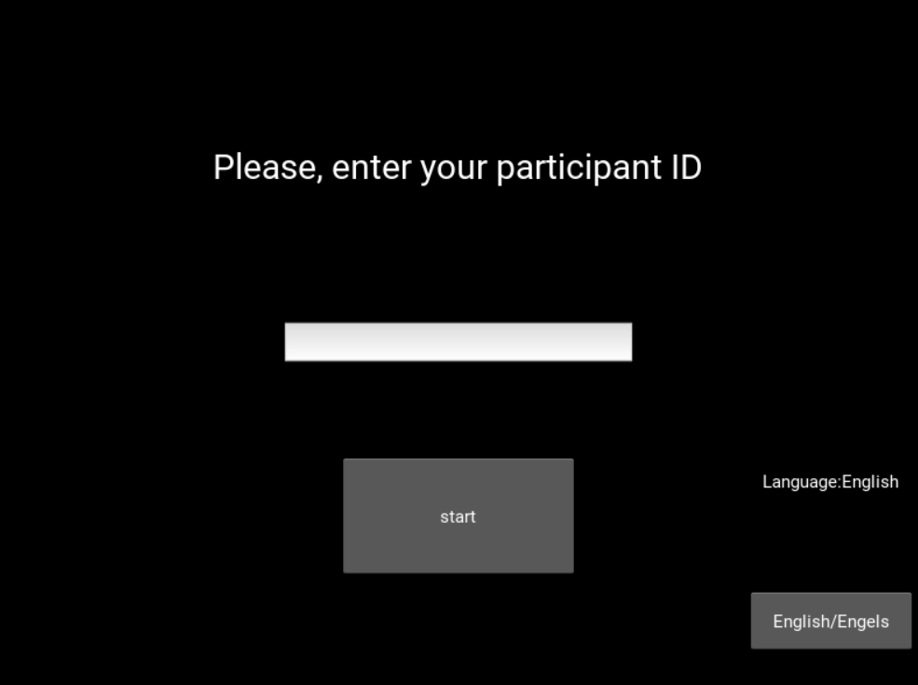 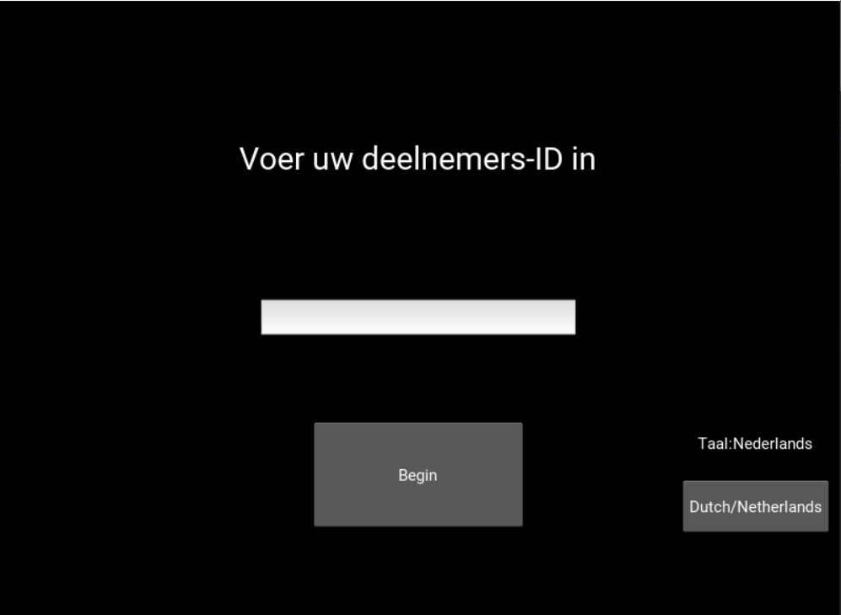

1. Press the start button to start the game.

2 Brief introduction:

Before you start the game, the robot will give you a brief introduction of this game; also, the text version of the robot said will display on the screen to make sure that you won't miss anything. If you forget the rules or miss some content of the introduction, you could still press the "rules" button to know the detailed rules of this game.

3The explanation of the game :

Participants were going to see 30 air balloons, one after the other. During 30 trials, participants were asked to press the 'pump balloon' button to inflate a balloon displayed on the computer monitor. You can pump at most 127 times. Be careful! Balloons can pop at any time! Some might even pop after a single pump. Each pump is worth 0.01 euro: the more you pump, the more you earn! Thus, participants inflated 30 different balloons, the balloon was inflated by 1, and 1 cent (Europe currency) was added to the participant's "temporary piggy money bank," which was shown on the screen. This represented the sum earnings for the current balloon. After each pump, a "collect reward" button displayed on the screen could be clicked by the participant to "cash in" the winnings for the current balloon. By clicking the button, the participant moved on immediately to the next balloon, and the winnings for the previous balloon were added to the participant's overall earnings, also displayed on the screen. If, however, the balloon exploded after a pump was made, all winnings for that balloon were lost, and participants moved on to the next balloon without adding to their overall earnings,

Attention: the participants can also quit the game by the "quit" button; the participants won't earn any money if they leave before the end of the game.

**4 Questionnaire**

After the game, participants will be brought to another room to fill out two questionnaires, one about happiness state and another is about trust.

As for happiness :

4.1 As for happiness state:

1)Mark the robot's different feelings from your perspective

1)Mark your feeling

4.2 Trust

**Nao robot:**

You will see one robot in this experiment, which is set in three modes. Enjoy the game with them.

**Mode** 1

In this game, you will have one partner to accomplish this game with you, you can see him on the desk, yes, he is a robot, and he will try to play this game with you together， sometimes， he will ask you to have some interaction with him, such as high-five, shake hands, and he might hope you to stroking his head, please give him some responses, have fun with Nao.

**Mode 2**

In this game, you will have one partner to accomplish this game with you, you can see him on the desk, yes, he is a robot, and he will try to play this game with you together. Please put him on your lap after he gives you a brief introduction to the game. Therefore they could see what you are doing and then play the game together.

Note: Please be careful, take care of the robot's arm, and avoid disturbing this robot's arm when he is moving.

**Mode** 3

In this game, you will have one partner to accomplish this game with you, you can see him on the desk, yes, he is a robot, and he will try to play this game with you together, and have fun with Nao.